USA
United States The United States, too, often uses the acronym U.S., except that it is published in central North America, which stretches from the Atlantic in the east to the Pacific Ocean in the west. The state consists of 50 federal states, which have local autonomy in accordance with the federal system. Citizens of the United States are commonly referred to as Americans.The United States of America were created by the Declaration of the Thirteen British Colonies in 1776. by which they established their freedom and independence.With 9.83 million km2 and over 300 million inhabitants, the United States is the third largest country in the world in terms of total area, and the third in terms of land size and population. The United States is one of the most ethnically diverse countries in the world, as a result of mass immigration from many countries, especially during the First and Second World Wars.
In the 19th century, the United States appropriated territories belonging to New France, Spain, Great Britain, Mexico, and the Russian Empire, and annexed the Republic of Texas and Hawaii. Disputes between the agrarian south and the industrial north over state rights and the expansion of slavery led to the American Civil War during the 1860s. The victory of the North prevented the permanent division of the country, and then the abolition of slavery. The Spanish-American War and World War I confirmed the position of the United States as a military power. In 1945. the United States emerged from World War II as the first nuclear-weapon country, a permanent member of the United Nations Security Council, and the founder of NATO.
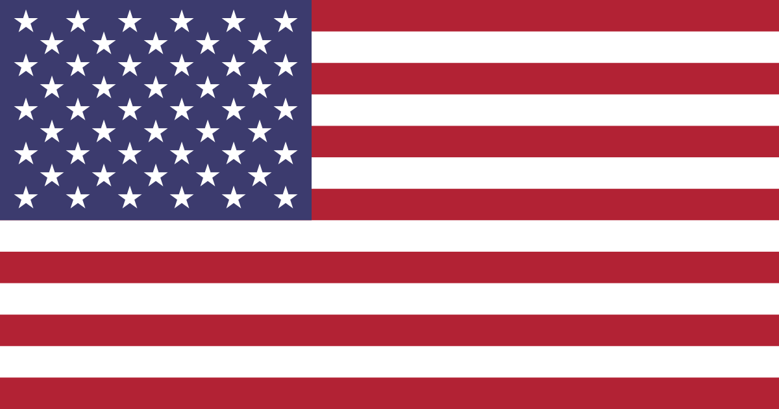This is the flag of the United States.

And this is US President (Donald Trump)
